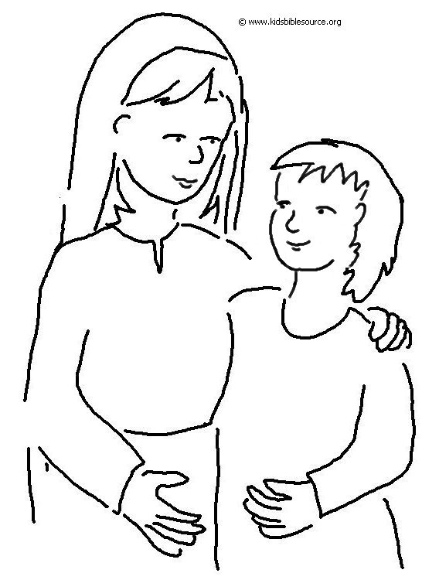
Even children are known by the way they
act.
Proverbs 20:11_{NLT}

